Rationale:
Understanding the connection between probability and expected value is an important skill to have. There are many times that knowing the expected costs can be beneficial to you: knowing whether to take a warranty on the purchase of a new television, whether the insurance policy you are taking is priced correctly, or even predicting how much money you are likely to spend when you go out to eat with your friends on the weekend can all use expected value to help you make decisions.

Instructions:
In this assignment, you will analyze the results of a carnival game for a school fund raiser. You should use Probability and the principles of Expected Value to analyze the game and answer the following questions. Your group should determine the theoretical probability of the game first. Then, each member of your group should simulate the game to determine your own experimental probability. Once both probabilities have been found, your group will discuss implications on the similarity of the two probabilities. Your group will determine the expected value of the game from the school's perspective. You will then make a rational recommendation to the school about the game.
You will use the Word Document below to record your answers. Once you have completed the assignment, you will click on submit above and attach the completed word file to this assignment.
Your answers are recorded in this document: Project 5 Answer Sheet.docx

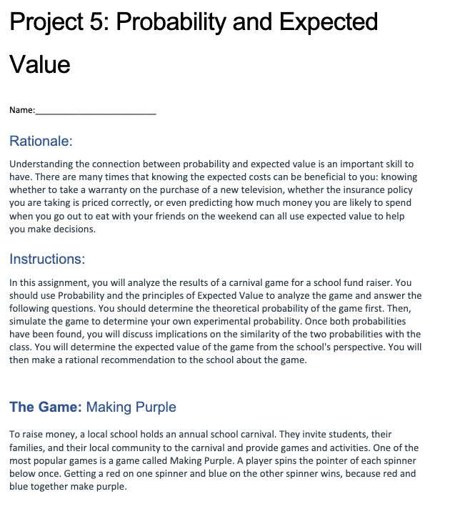

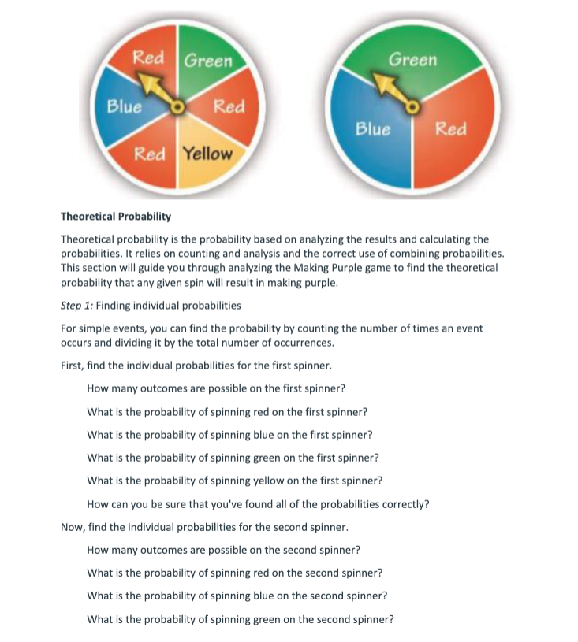
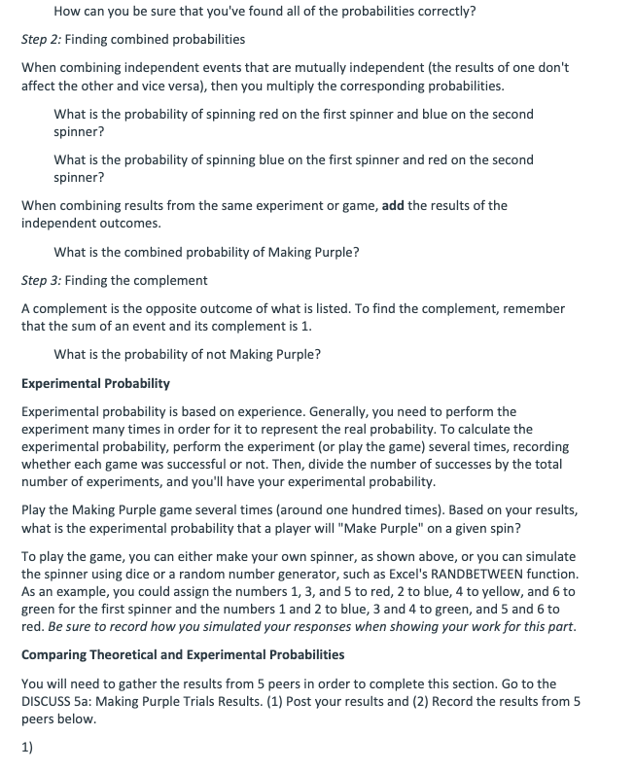
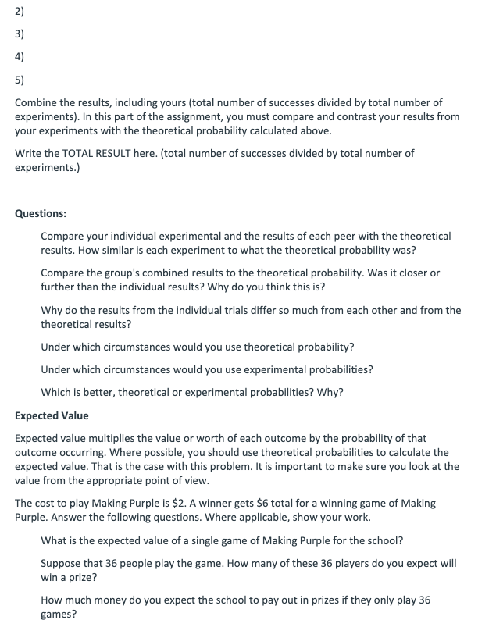
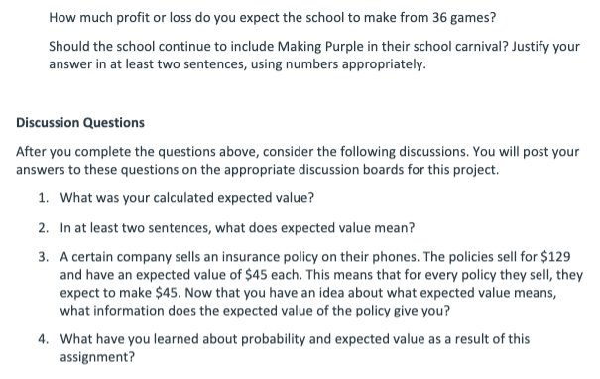

The Game:
Making Purple
To raise money, a local school holds an annual school carnival. They invite students, their families, and their local community to the carnival and provide games and activities. One of the most popular games is a game called Making Purple. A player spins the pointer of each spinner below once. Getting a red on one spinner and blue on the other spinner wins, because red and blue together make purple.


Part 1: Theoretical Probability
Theoretical probability is the probability based on analyzing the results and calculating the probabilities. It relies on counting and analysis and the correct use of combining probabilities. This section will guide you through analyzing the Making Purple game to find the theoretical probability that any given spin will result in making purple.
Step 1: Finding Individual Probabilities
For simple events, you can find the probability by counting the number of times an event occurs and dividing it by the total number of occurrences.
Answer the questions found in Project 5 Answer Sheet.docx

Step 2: Finding Combined Probabilities
When combining independent events that are mutually independent (the results of one don't affect the other and vice versa), then you multiply the corresponding probabilities.
Answer the questions found in Project 5 Answer Sheet.docx

Step 3: Finding the Complement
A complement is the opposite outcome of what is listed. To find the complement, remember that the sum of an event and its complement is 1.
Answer the questions found in Project 5 Answer Sheet.docx

Part 2: Experimental Probability
Experimental probability is based on experience. Generally, you need to perform the experiment many times in order for it to represent the real probability. To calculate the experimental probability, perform the experiment (or play the game) several times, recording whether each game was successful or not. Then, divide the number of successes by the total number of experiments, and you'll have your experimental probability.
Play the Making Purple game several times (around one hundred times). Then, answer the questions found in Project 5 Answer Sheet.docx

Part 3: Comparing Theoretical and Experimental Probabilities
You will need to gather the results from 5 peers in order to complete this section. Go to the DISCUSS 5a: Making Purple Trials Results. (1) Post your results and (2) Record the results from 5 peers in the spaces found in Project 5 Answer Sheet.docx
.
Combine the results of each of the six trials (yours included). The results are the number of successes divided by total number of experiments. In this part of the assignment, you must compare and contrast your results from your experiments with the theoretical probability calculated above.
Record the total experimental probability in Project 5 Answer Sheet.docx
.

Part 4: Expected Value
Expected value multiplies the value or worth of each outcome by the probability of that outcome occurring. Where possible, you should use theoretical probabilities to calculate the expected value. That is the case with this problem. It is important to make sure you look at the value from the appropriate point of view.
The cost to play Making Purple is $2. A winner gets $6 total for a winning game of Making Purple. Answer the questions found in Project 5 Answer Sheet.docx
.
